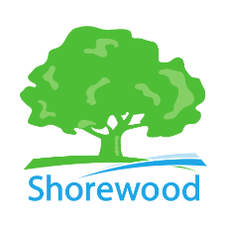
Utility Customer Update

Sewer Rate Adjustment – 2026
The Village of Shorewood Board of Trustees approved a sewer rate adjustment as part of the 2026 budget. The sewer utility is funded entirely by user fees. This rate adjustment reflects:
- Continued investment in sewer infrastructure
- Rising operating and maintenance costs
- Increased MMSD connection charges
- The need to maintain the long-term financial stability of the sewer utility
What is changing?
The sewer volume charge will increase by $2.57 per 1,000 gallons, bringing the total to $14.26 per 1,000 gallons. The connection fee has also been adjusted to $20.06 to reflect increased regional costs.
The volume charge is based on how much water your household uses. A typical residential customer using approximately 11,000 gallons per quarter will see an increase of about $32 per quarter.
This adjustment helps ensure reliable sewer service, supports ongoing infrastructure needs, and reduces the risk of larger or more disruptive rate increases in the future.

Streetlight Charge Adjustment for Corner Lots – 2026
The Village of Shorewood Board of Trustees approved a modification to the streetlight charge for 2026. Corner lots are now charged based upon the shortest side of the lot that fronts the street, but not less than 40 feet.
The charge was recalculated to accommodate this change for corner lots. In 2025 the charge was $4.46 per lineal foot. In 2026 the annual charge per property will be $4.84 per lineal foot, divided equally between quarterly utility bills. Visit the Streetlight Charge GIS link to view your property’s specific lineal footage and charge information.

Water Increase – Anticipated May 2026
Water utility rates are set by the Public Service Commission (PSC). The Village applied for a rate increase January 2025. The PSC has not yet determined rates. The Village hopes to receive the rates in late spring, implementing the new rates on the May utility bill.
Questions? Contact the Department of Public Works at (414) 847 - 2650

